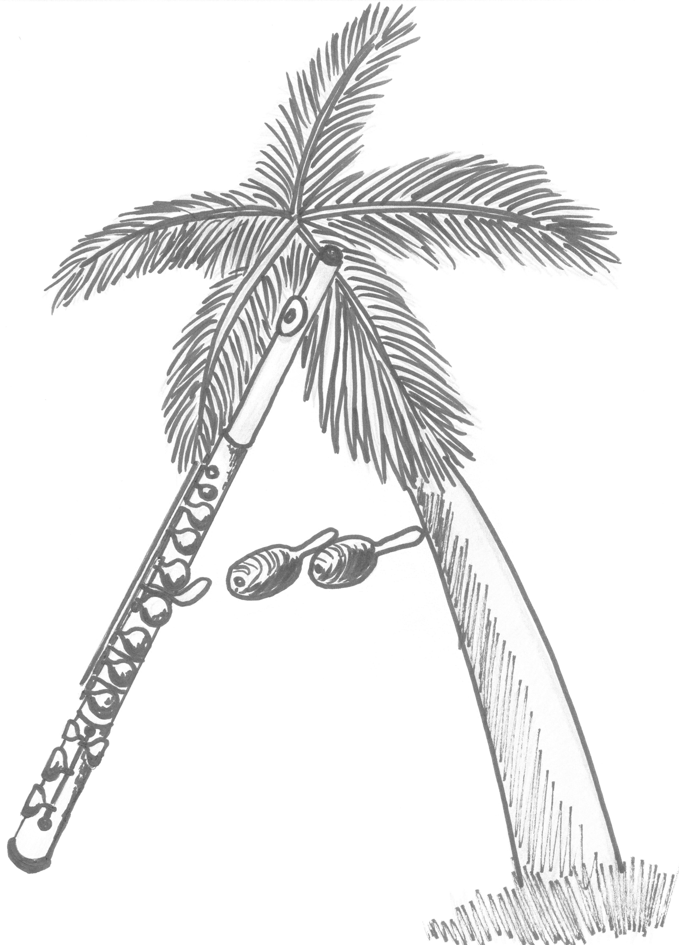 | Ana de la Cuesta  Flutist  Specialist in Cuban Traditional Music Interpretation
7204 Hammet Road  Tampa, FL 33647 (USA) |  | Telephone: 1-813-252-3574  Email: alcuesta@aol.com

What Ana Offers
- Superb flute performing in small or large groups
- An exciting soloist act, with her own MIDI-generated accompaniment
  - This approach means that the sonority of her selections is not limited to a particular combination of instruments. She can accompany herself, for example, with a piano; with a harp, guitar or other strings; with a wide range of Cuban percussion instruments; or with any desirable combination of the above or of other instruments. To the delight of her audiences, her accompaniment conforms optimally to the demands of the music she is playing. No small live group has such flexibility.
- Exquisitely lyrical Cuban traditional music − with an ability to explain as well as play it
Ana’s Background
- Born and raised in Havana, Cuba
- Studied music at Cuba’s leading conservatories and pedagogical institutes, as well as privately with the renowned Cuban flutist, Professor Luis Bayard
- Performed classical music in the Cuban National Symphony Orchestra, the National Center of Concert Music (a series of solo concerts), and various small groups
- Performed international, popular and Cuban traditional music (with piano or guitar accompaniment), in the Orchestra of the Musical Theater of Havana, and in various groups
  - Helped found two: the Juglar Trio (Rennaissance minstrel music) and the Doña Irene Orchestra (playing danzones, Cuban national dance music)
  - With the collapse of the Cuban economy in the early 1990s, resourcefully stayed “above water” by free-lancing in the Cuban tourism sector
- Served all the while as a full-time teacher of flute and music theory
- Moved to the U.S. (Wisconsin) in early 1998, to Florida in 2017
- Completed her Master of Music degree at the University of Wisconsin−Milwaukee
  - Wrote her thesis on “The Cuban Son” (a musical genre)
- Continued free-lance performing and flute teaching
- Trained herself in MIDI instrumentation, using a workstation and digital audio software
- Issued her first commercial CD, “Cuban Heart” − a collection of Cuban traditional music with her as both performer and orchestrator
Ana’s Guiding Belief
Cuban traditional music is a rich treasure that far too few Americans are exposed to. Those who have been invariably fall in love with it.

